Batch: B2 Roll No.: 16010122158

Experiment 07

Title: To create an effective Dashboard in Tableau.

Objective:

Search/locate and download any Data of Your Choice (Use same dataset if it contains location information)

To learn how to create Dashboard in Tableau

Apply best practices to create Tableau Dashboard.

Course Outcome:

CO1: Learn how to locate and download datasets, extract insights from that data and present their findings in a variety of different formats.

CO3 Create compelling, interactive dashboards to combine several visualizations into a cohesive and functional whole.

Books/ Journals/ Websites referred:
https://vitalflux.com/dashboard-purpose-advantages-disadvantages/

Resources used:

Tableau

Theory:
A dashboard is a visual representation of the most important information needed to achieve a goal. Dashboards form an integral part of analytical solutions and can provide an overview of what is happening in your business and help you make better decisions.

A dashboard is a visual display of data and information that is typically used to provide an overview of a company or organization’s performance. Dashboards can be said to be digital tools that help users to see and understand data. The purpose of a dashboard is to help users quickly understand the current state of affairs by providing a high-level view of key metrics including value metrics and key performance indicators (KPIs). Dashboards are often used in conjunction with analytics tools to help users drill down into the underlying data to identify trends, benchmark performance, and make informed decisions. Dashboards can be customized to display the specific data and information that is most relevant to the user, making them an invaluable tool for business intelligence.

Following points should be written by students

Best practices of effective Dashboard.

Know your purpose and audience.

Leverage the most-viewed spot.

Design for the real world.

Author at your final display size.

Limit the number of views.

Add interactivity to encourage exploration.

Create a Dashboard.

Create an Accessible Dashboard.

Create Dashboard Layouts for Different Device Types.

Dashboard Layout for Desktop
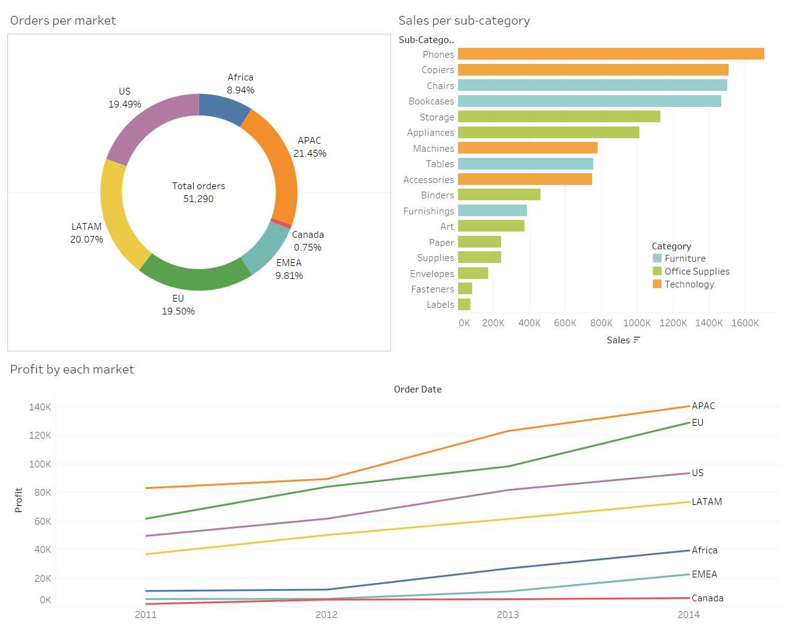

Dashboard Layout for Phone

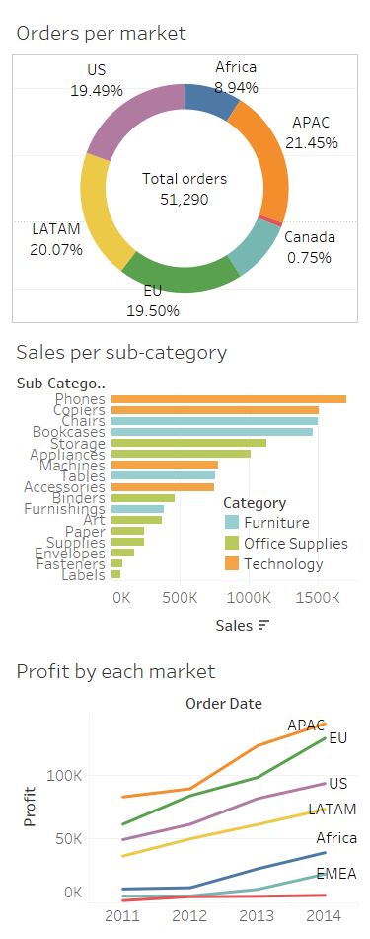

Conclusion (Students should write in their own words, comparative conclusion needed):

Downloaded dataset. Learnt how to create a dashboard in Tableau.

Created accessible dashboard and dashboard layouts for different device types.

Post Lab Question:

Explain the Advantages and Disadvantages of Dashboard
Advantages:
- Decision-making aid: Dashboards can be used to track progress, monitor and spot trends over time, provide valuable insights into customer behavior and market changes, and make better decisions.
- Identify business opportunities: By bringing together key data points and metrics, they provide a quick and easy way to track progress and identify areas of opportunities.
- Easy to share: Dashboards make it easy to share information with others, whether it’s through email, social media, or embedding the dashboard on a website. Dashboard screenshots can be easily used in PowerPoint presentations.
- Business & personal usage: Dashboards can be used for both business and personal use.
Disadvantages:
- Dashboards can be overwhelming, particularly if they try to pack in too much information. It can be difficult for users to know where to look and what is most important.
- Dashboards are often static, meaning that they don’t update in real-time as data changes. This can make them less useful for tracking fast-moving trends.
- Dashboards can get difficult to customize, meaning that users may not be able to tailor them to their specific needs. For these reasons, dashboards should be used carefully and only when they offer the best way to visualize the desired data.
- Dashboards can also be misleading if they are not used correctly. It is easy to cherry-pick data (data bias) that supports a particular argument while ignoring data that does not. This is also called confirmation bias. As a result, dashboards should be used carefully and only as one part of a broader analytical approach.
Date: 22/10/2023 Signature of faculty in-charge

